01. JavaFX

- Introduction

The following shows how to use NetBeans IDE to create a JavaFX application.
- From the File menu, choose New Project.
- In the JavaFX application category, choose JavaFX Application. Click Next.
- Enter the name of the project, and click Finish.

NetBeans IDE creates a JavaFX application with a .java file as below.

public class HelloWorld extends Application
{
@Override
public void start(Stage primaryStage)
{
Button btn = new Button();
btn.setText("Hello World");
btn.setOnAction(new EventHandler<ActionEvent>()
{
@Override
public void handle(ActionEvent event)
{
System.out.println("Hello World!");
}
});

StackPane root = new StackPane();
root.getChildren().add(btn);

Scene scene = new Scene(root, 300, 250);

primaryStage.setTitle("Hello World");
primaryStage.setScene(scene);
primaryStage.show();
}

public static void main(String[] args)
{
launch(args);
}
}

Application

The main class for a JavaFX application extends the Application class. You can terminate a JavaFX Application by calling the Platform.exit() method explicitly or by closing the window. When a JavaFX Application is terminated, the Application.stop() method will be executed.

Stage

The Stage class is top level JavaFX container.
- The setTitle method sets the value of the title.
- The setScene method specifies the scene to be used on the stage.
- The show method shows the window by setting visibility to true.

Scene

The Scene class is the container for all content in a scene graph. A scene must have a root node, which is either a layout container or a Group object.

Text text = new Text(10, 40, "Hello World!");

Group root = new Group();
root.getChildren().add(text);

Scene scene = new Scene(root);

- Layout

JavaFX includes the following layout classes.

Class | Description
StackPane | It places its content nodes in a back-to-front single stack.
HBox | It arranges its content nodes horizontally in a single row.
VBox | It arranges its content nodes vertically in a single row.
GridPane | It creates a flexible grid of rows and columns in which to lay out content nodes.
BorderPane | It lays out its content nodes in the top, bottom, right, left, or center region.
FlowPane | It arranges its content nodes consecutively and wrap at the boundary set for the pane.
TilePane | It places the nodes in a grid in which each cell is the same size.
AnchorPane | It creates anchor nodes to the top, bottom, left side, or center of the layout.

The following shows how to use the HBox class.

HBox box = new HBox();

Button btn1 = new Button("Save");
Button btn2 = new Button("Cancel");

box.getChildren().addAll(btn1, btn2);

The following shows how to use the GridPane class.

GridPane grid = new GridPane();

Text text1 = new Text("Name:");
grid.add(text1, 1, 0);

Text text2 = new Text("Mike");
grid.add(text2, 1, 1);

- UI Controls

JavaFX provides the following UI controls.

Class | Description
Label | Creates a label.
TextField | Creates a text field.
Button | Creates a button.
CheckBox | Creates a check box.
RadioButton | Creates a radio button.
ToggleButton | Creates a toggle button.
ComboBox | Creates a combo box.
ChoiceBox | Creates a choice box.
ListView | Creates a list view.
Slider | Creates a slider.
ProgressBar | Creates a progress bar.
Hyperlink | Creates a hyper link.
ScrollPane | Creates a scroll pane.
Menu | Creates a menu.
ColorPicker | Creates a color picker.
DatePicker | Creates a date picker.
TableView | Creates a table view.
TreeView | Creates a tree view.
FileChooser | Creates a file chooser.
HTMLEditor | Creates an HTML editor.
Pagination | Creates a pagination control.
Accordion | Creates an accordion control.
TabPane | Creates a tab control.

Example:
TextField text1 = new TextField();
TextField text2 = new TextField();

CheckBox cb1 = new CheckBox("First");
CheckBox cb2 = new CheckBox("Second");

Button submit = new Button("Submit");

submit.setOnAction((ActionEvent e) ->
{
text2.setText(text1.getText());
});

The ToggleGroup object is usually used to group a list of radio buttons or toggle buttons.

RadioButton rb1 = new RadioButton("Red");
RadioButton rb2 = new RadioButton("Green");
RadioButton rb3 = new RadioButton("Blue");

ToggleGroup group = new ToggleGroup();

rb1.setToggleGroup(group);
rb2.setToggleGroup(group);
rb3.setToggleGroup(group);

ChoiceBox and ComboBox are similar. The difference is that a ComboBox will add scrolling when the number of items to show exceeds some limit.

ComboBox cb = new ComboBox();
cb.setItems(FXCollections.observableArrayList("Apple", "Orange", "Peach", "Pear", "Cherry"));

cb.getSelectionModel().selectedItemProperty().addListener(new ChangeListener<String>()
{
@Override
public void changed(ObservableValue<? extends String> value, String oldVal, String newVal)
{
…
}
});

- Styling with CSS

You can use cascading style sheets (CSS) to control the look of UI elements. Styles property names are preceded by "-fx-". The following defines a CSS file.

.button {
-fx-text-fill: rgb(49, 89, 23);
-fx-border-color: rgb(49, 89, 23);
-fx-border-radius: 5;
-fx-padding: 3 6 6 6;
}

.custom-button {
-fx-font: 16px "Serif";
-fx-padding: 10;
-fx-background-color: #CCFF99;
}

#font-button {
-fx-font: bold italic 20pt "Arial";
-fx-effect: dropshadow( one-pass-box , black , 8 , 0.0 , 2 , 0 );
}

The following shows how to apply the style sheets to the controls.

Scene scene = new Scene(root, 500, 400);
scene.getStylesheets().add("styles/file1.css");

Button btn1 = new Button("Accept");
btn1.getStyleClass().add("custom-button");

Button btn2 = new Button("Font");
btn2.setId("font-button");

You can also apply inline styles to the UI controls directly.

Button btn3 = new Button("Color");
btn3.setStyle("-fx-background-color: slateblue; -fx-text-fill: white;");

- FXML

FXML is an XML-based declarative markup language for building the user interface for your JavaFX application. When you create a JavaFX FXML application, NetBeans IDE automatically creates three files. The FXMLDocument.fxml file contains the FXML markup which defines the user interface.

<AnchorPane id="AnchorPane" prefHeight="200" prefWidth="320"
xmlns:fx="http://javafx.com/fxml/1"
fx:controller="HelloWorld.FXMLDocumentController">
<children>
<Button layoutX="126" layoutY="90" text="Hello" onAction="#HelloClick" fx:id="button" />
<Label layoutX="126" layoutY="120" minHeight="16" minWidth="69" fx:id="label" />
</children>
</AnchorPane>

The FXMLDocumentController.java file is the controller for handling the mouse and keyboard events.

public class FXMLDocumentController implements Initializable
{
@FXML
private Label label;

@FXML
private void HelloClick(ActionEvent event)
{
label.setText("Hello World");
}

@Override
public void initialize(URL url, ResourceBundle rb)
{
// TODO
}
}

The HelloWorld.java file creates an Application object, which is the entry point of the application.

public class HelloWorld extends Application
{
@Override
public void start(Stage stage) throws Exception
{
Parent root = FXMLLoader.load(getClass().getResource("FXMLDocument.fxml"));
Scene scene = new Scene(root);

stage.setScene(scene);
stage.show();
}

public static void main(String[] args)
{
launch(args);
}
}

To use a style sheet, you can add a <stylesheets> element in the FXML file, and specify the styleClass or id attribute of the elements with the related value.

<AnchorPane ... styleClass="root">

<Label id="welcome-text" ... />
<Text id="welcome-input" ... />

<stylesheets>
<URL value="@styles.css" />
</stylesheets>
</AnchorPane>

JavaFX Scene Builder provides a visual layout environment that lets you quickly design user interfaces for JavaFX applications without needing to write any code. You can build the user interface by simply dragging and dropping the GUI components onto a JavaFX scene. The FXML code for the layout will be automatically generated. You can download JavaFX Scene Builder from http://www.oracle.com/technetwork/java/javase/downloads.

- Text

The Text class is used to display text.

Text t1 = new Text();
t1.setText("Hello World");

Text t2 = new Text("How are you");
Text t3 = new Text (10, 20, "Thank you");

The following shows how to change the properties of a Text object.

t1.setText("Hello World");
t1.setFont(Font.font ("Verdana", FontWeight.BOLD, 20));
t1.setFill(Color.RED);

- WebView

The WebView component is used to embed Web pages within a JavaFX application.

WebView view = new WebView();
WebEngine engine = view.getEngine();

engine.load("http://www.google.com");

You can call the JavaScript function defined in the HTML page from your Java code.

// index.html
…
<script>
function display(name)
{
window.alert('Hi ' + name);
}
</script>

// Java code
Button btn1 = new Button("Hello");

btn1.setOnAction((ActionEvent t) ->
{
String name = txtName.getText();
engine.executeScript("display('" + name + "')");
});

In order to execute the Java code in the JavaScript, you need to create an interface object and make it known to JavaScript by calling the JSObject.setMember method.

// JavaScript interface object
public class JavaApp
{
public void exit()
{
Platform.exit();
}
}

// Java code
JSObject win = (JSObject) engine.executeScript("window");
win.setMember("app", new JavaApp());

// JavaScript
<a href="about:blank" onclick="app.exit()">Goodbye</a>

- Chart

JavaFX provides the following charts.

Type | Description
PieChart | Draws a pie chart.
LineChart | Draws a line chart.
AreaChart | Draws an area chart.
BarChart | Draws a bar chart.

The PieChart represents data in a form of circle divided into slices.

PieChart chart = new PieChart(FXCollections.observableArrayList(
new PieChart.Data("Grape", 15),
new PieChart.Data("Orange", 25),
new PieChart.Data("Plum", 15),
new PieChart.Data("Pear", 20),
new PieChart.Data("Apple", 25)));

chart.setTitle("Fruits");
chart.setLabelLineLength(10);
chart.setLegendSide(Side.LEFT);

Group root = new Group();
root.getChildren().add(chart);

The following shows the pie chart.

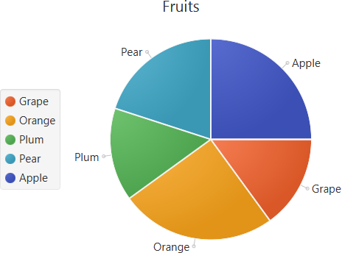

The LineChart represents data as a series of points connected by straight lines. The NumberAxis class is used to render numerical data in a line chart. The CategoryAxis class is used to render non-numerical data in a line chart.

CategoryAxis xAxis = new CategoryAxis();
NumberAxis yAxis = new NumberAxis();

LineChart<String, Number> chart = new LineChart<String, Number>(xAxis, yAxis);
chart.setTitle("Stock Monitoring, 2016");
xAxis.setLabel("Month");

XYChart.Series series1 = new XYChart.Series();
series1.setName("California");

series1.getData().add(new XYChart.Data("Jan", 23));
series1.getData().add(new XYChart.Data("Feb", 14));
series1.getData().add(new XYChart.Data("Mar", 15));
series1.getData().add(new XYChart.Data("Apr", 24));
series1.getData().add(new XYChart.Data("May", 34));
series1.getData().add(new XYChart.Data("Jun", 36));
series1.getData().add(new XYChart.Data("Jul", 22));
series1.getData().add(new XYChart.Data("Aug", 45));
series1.getData().add(new XYChart.Data("Sep", 43));
series1.getData().add(new XYChart.Data("Oct", 17));
series1.getData().add(new XYChart.Data("Nov", 29));
series1.getData().add(new XYChart.Data("Dec", 25));

XYChart.Series series2 = new XYChart.Series();
series2.setName("Arizona");

series2.getData().add(new XYChart.Data("Jan", 33));
series2.getData().add(new XYChart.Data("Feb", 34));
series2.getData().add(new XYChart.Data("Mar", 25));
series2.getData().add(new XYChart.Data("Apr", 44));
series2.getData().add(new XYChart.Data("May", 39));
series2.getData().add(new XYChart.Data("Jun", 16));
series2.getData().add(new XYChart.Data("Jul", 55));
series2.getData().add(new XYChart.Data("Aug", 54));
series2.getData().add(new XYChart.Data("Sep", 48));
series2.getData().add(new XYChart.Data("Oct", 27));
series2.getData().add(new XYChart.Data("Nov", 37));
series2.getData().add(new XYChart.Data("Dec", 29));

chart.getData().addAll(series1, series2);

The following shows the line chart.

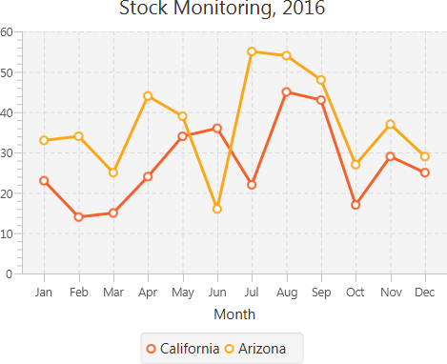

The AreaChart represents data as a series of points connected by straight lines. The area is painted with color.

final NumberAxis xAxis = new NumberAxis(1, 31, 1);
final NumberAxis yAxis = new NumberAxis();

final AreaChart<Number, Number> chart = new AreaChart<>(xAxis, yAxis);
chart.setTitle("Temperature Monitoring (in Degrees C)");

XYChart.Series series1= new XYChart.Series();
series1.setName("April");

series1.getData().add(new XYChart.Data(1, 4));
series1.getData().add(new XYChart.Data(3, 10));
series1.getData().add(new XYChart.Data(6, 15));
series1.getData().add(new XYChart.Data(9, 8));
series1.getData().add(new XYChart.Data(12, 5));
series1.getData().add(new XYChart.Data(15, 18));
series1.getData().add(new XYChart.Data(18, 15));
series1.getData().add(new XYChart.Data(21, 13));
series1.getData().add(new XYChart.Data(24, 19));
series1.getData().add(new XYChart.Data(27, 21));
series1.getData().add(new XYChart.Data(30, 21));

XYChart.Series series2 = new XYChart.Series();
series2.setName("May");

series2.getData().add(new XYChart.Data(1, 20));
series2.getData().add(new XYChart.Data(3, 15));
series2.getData().add(new XYChart.Data(6, 13));
series2.getData().add(new XYChart.Data(9, 12));
series2.getData().add(new XYChart.Data(12, 14));
series2.getData().add(new XYChart.Data(15, 18));
series2.getData().add(new XYChart.Data(18, 25));
series2.getData().add(new XYChart.Data(21, 25));
series2.getData().add(new XYChart.Data(24, 23));
series2.getData().add(new XYChart.Data(27, 26));
series2.getData().add(new XYChart.Data(31, 26));

chart.getData().addAll(series1, series2);

The following shows the area chart.

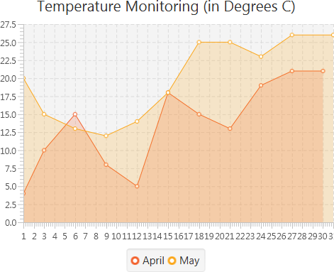

The BarChart represents data as rectangular bars that can be either vertical or horizontal.

final CategoryAxis xAxis = new CategoryAxis();
final NumberAxis yAxis = new NumberAxis();
final BarChart<String, Number> chart = new BarChart<>(xAxis, yAxis);

xAxis.setLabel("Country");
yAxis.setLabel("Value");
chart.setTitle("Country Summary");

XYChart.Series series1 = new XYChart.Series();
series1.setName("2015");

series1.getData().add(new XYChart.Data("Austria", 25601.34));
series1.getData().add(new XYChart.Data("Brazil", 20148.82));
series1.getData().add(new XYChart.Data("France", 10000));
series1.getData().add(new XYChart.Data("Italy", 35407.15));
series1.getData().add(new XYChart.Data("USA", 12000));

XYChart.Series series2 = new XYChart.Series();
series2.setName("2016");

series2.getData().add(new XYChart.Data("Austria", 57401.85));
series2.getData().add(new XYChart.Data("Brazil", 41941.19));
series2.getData().add(new XYChart.Data("France", 45263.37));
series2.getData().add(new XYChart.Data("Italy", 117320.16));
series2.getData().add(new XYChart.Data("USA", 14845.27));

chart.getData().addAll(series1, series2);

The following shows the bar chart.

